1 Related Work and Motivation
Pareto dominance relations are widely used in MOEA to rank candidate solution levels. To minimize the MOP, the candidate solution $x$is said to be Pareto-dominated $y$, denoted by $f(x)≺f(y)$, if and only if
$\left\{\begin{aligned}∀ i∈ 1,...,m :f_{i}(x)≤f_{i}(y) \\ ∃ j∈1,...,m :f_{j}(x)<f_{j}(y)\end{aligned}\right.$ (1)
where$F(x)=(f_{1}(x),f_{2}(x),...,f_{m}(x))$ denotes the objective value of $x$ and $m$ is the objective number. If $x$ does not dominate $y$ and $y$ also does not dominate $x$, then the two candidate solutions are said to be mutually non-dominated. According to Eq. (1), for two random candidate solutions in the $m$-objective problem, the probability of one candidate dominating the other is $1/2^{m−1}$ and it decreases exponentially with the increase of objective number $m$. This causes the dominance-based method to face insufficient selection pressure, the phenomenon called Dominance Resistance (DR) [1]. In order to address this problem, some algorithms have been proposed to alleviate the comparability between the two candidate solutions, which can be broadly classified into four categories and we will next briefly review these typical dominance relations.
1.1 Related Work
(1) Expanding the Dominance Area
The representative method in this category is the Control Dominance Areas with Solutions(CDAS) [2]. It extends the dominance area of the solution by modifying the fitness function of the objective function through the user-defined parameter $S$ using the Eq. (2):
$f_{i}^{'}(x)=\frac{||f(x)||sin(α_{i}+S∙π)}{sin(S∙π)} , i=1,...,m$ (2)
where $f_{i}^{'}(x)$ denotes the $i$-th objective value of $x$ after transformation, $||∙||$ denotes $L_{2}$-norm,${ α}_{i }$denotes the declination between $x$ and the i-th axis,$S$ is the control parameter for the degree of $x$ expansion and $S∈[0.25, 0,5]$. When$S$is greater than 0.5, the dominant area gradually shrank.
To eliminate the effect of parameter $S$, an adaptive CDAS (S-CADS) is proposed [3], where the expansion degree of S-CDAS candidate solution $x$ is determined adaptively based on the extreme solutions in the population:
$f_{i}^{'}(x)=\frac{||f(x)||sin(α_{i}+φ_{i})}{sin(φ_{i})}， i=1,...,m$ (3)
where
${ φ}_{i}=arcsin\frac{||f(x)||∙sin(ω_{i})}{||f(x)−e_{i}||}$ (4)
$e_{i}$ denotes the extreme solution on the $i$-th axis in the population.
- Objective Space Gridding
A typical method in this category is grid dominance. In grid dominance, the grid coordinates$G(x)=(g_{1}(x),g_{2}(x),...,g_{m}(x))$ of the solution are calculated using Eq. (5), (6) and (7):
$G_{i}(x)=\left\lfloor (F_{i}(x)−lb_{i})/d_{i}\right\rfloor$ (5)
where $\left\lfloor ∙\right\rfloor$ denotes the floor function.
The upper and lower boundaries of the grid in the $i$-th objective are determined according to the Eq. (6) :
$\left\{\begin{aligned}{ub}_{i}=\max_{i}(P)+(\max_{i}(P)−\min_{i}(P))/div/2 \\ {lb}_{i}=\min_{i}(P)−(\max_{i}(P)−\min_{i}(P))/div/2\end{aligned}\right.$ (6)
where $\max_{i}(P)$ and $\min_{i}(P)$ denote the $i$-th maximum value and minimum value in the population, respectively, and $μ$ is a parameter of the number of divisions for each objective.
Thus, the original $m$-dimensional objective space is divided into $μ^{ m}$ hyperboxes, and the width of each hyperbox is expressed as follows:
$d_{i}=({ub}_{i}−{lb}_{i})/μ$ (7)
Use grid coordinates to determine the dominance relation instead of using objective values. The grid dominance is also a relaxed Pareto dominance, but it is seriously affected by the parameter $μ$.
(3) Fuzzy Logic
- $k$)-dominance [4],$L$-dominance [5] and fuzzy dominance belong to this category. In this type of method, the criterion for determining the dominance relation are usually considered, as the objective number of one candidate solution is smaller or larger than the other. In (1-$k$) dominance, if and only if
$\left\{\begin{aligned}n_{e}<m \\ n_{s}≥\frac{m−n_{e}}{k+1}\end{aligned}\right.$ (8)
is called the solution $x$ (1-$k$)-dominate the solution $y$, where $n_{e }$and $n_{s}$ are the objectives number of $x$ equal to and less than $y$, respectively, and $k$ is a predefined parameter in the range of [0, 1]. Similar to $k$-dominance, for $L$-dominance, if and only if
$\left\{\begin{aligned}n_{s}>n_{g} \\ ||f(x)||<||f(y)||\end{aligned}\right.$ (9)
is called $x$ $L$-dominate $y$. Where $n_{s}$ and $n_{g}$ are the objective numbers where $x$ is less than and greater than $y$, respectively.
(4) Weight Vector Defines Dominance
This dominance relations are influenced by decomposition-based MaOEAs, which is defined by a set of weight vectors, such as $θ$-dominance [6]. In $θ$-dominance, when the non-dominated solution is associated with the same weight vector $ω$, each candidate solution is associated with its nearest weight vector, and
$d_{1}(x,ω)+θ∙d_{2}(x,ω)<d_{1}(y,ω)+θ∙d_{2}(y,ω)$ (10)
where $θ$ is the penalty parameter,
$\left\{\begin{aligned}d_{1}(x,ω)=\frac{||f(x)ω^{T}||}{||λ||} \\ d_{2}(x,ω)=||f(x)−d_{1}(x,ω)(ω/||ω||)||\end{aligned}\right.$ (11)
$θ$-dominance leads the solution to converge along the weight vector and and remain uniformly distribution in the population. When the distribution of the weight vectors is inconsistent with the PF, the performance of the algorithm will be seriously affected, because the number of weight vectors should be set to be the same as the population size.
Many-objective optimization problems have been effectively solved by using existing dominance relations, but there are still have defects in some dominance relations, which can only find a set of solutions that are concentrated on a small region of PF. Therefore, an adaptive niche dominance relation is proposed: the solutions can be distributed as evenly as possible on the PF and then adaptively select the convergence indicator that matches the the PF shape to improve the selection pressure, so as to achieve a balance between convergence and diversity.
- Reference Vector-Guided Evolutionary Algorithm
RVEA [7] can be considered as a decomposition-based algorithm or as a preference-driven MOEA. In RVEA, uniformly distributed reference vectors are generated by the regular simplex lattice design method [8]. After generating a set of reference vectors, the solutions in the population will be associated with different reference vectors based on the angles between the reference vectors and solutions. If the angle between the solution and the reference vector is the smallest of the angles between the solution and all the reference vectors, the solution will be assigned to the reference vector. The APD-based selection mechanism in RVEA aims to achieve a balance between convergence and diversity. Solutions with larger APD values will be more likely to survive. The pressure for convergence is controlled by the distance between the target value of the transformation and the ideal point, while diversity is facilitated by the angle between the solution and its associated reference vector.
- Adaptive Localized Decision Variable Analysis Approach
An adaptive local decision variable analysis method in a decomposition-based framework [9] is proposed to solve large-scale multi-objective optimization problems. The main idea is to incorporate the guidance of the reference vectors into the analysis of the control variables, and then, to optimize these grouped variables by means of an adaptive scalarization strategy. In particular, in the local control variable analysis, for each search direction, the convergence correlation of each decision variable is measured by a projection-based detection method. In decision variable optimization, the grouped decision variables are optimized using an adaptive scalarization strategy that adaptively balances the convergence and diversity of the solutions in the objective space, where the CRD is quantified based on the acute angle and the length of the projection in the direction of the bootstrap reference vector from the sampled solution.

1.2 Motivation
Although many efforts have been made to propose more efficient MaOEAs, we note that most dominance relations readily generate solution sets concentrated in a small region of the Pareto front, and that the density of solution sets in a small region directly affects diversity and convergence, especially in high-dimensional objective spaces. Therefore, we are motivated to propose a new dominance relation, A-NDR, which improves the selection pressure on the algorithms while increasing their performance by developing niche techniques based on the perspective between candidate solutions, and by generating a uniform set of solutions on the Pareto front with only one candidate solution with the best convergence in each niche. Most existing MaOEAs improve the performance of their algorithms mainly from the perspective of environment selection, with little attention paid to the effect of good parent individuals on the offspring and the generation of offspring; the common operations for selecting parent individuals are random selection and binary tournament selection, and the two common operations for generating offspring are crossover and mutation, which are mainly aimed at single-objective optimization. We abandon the traditional mutation strategy and use a small niche mating approach to select neighbours in the target space to solve k-bit crossover in order to avoid producing offspring identical to the parents and to improve the quality of the parents, and hybrid mutation to produce high-quality offspring, which contributes to the performance of the algorithm.

2. Experimental Results Analysis
2.1 Performance of DTLZ
The HV and IGD results for the six algorithms on the DTLZ test suite are given in Tab.1 and Tab.2, with the best results highlighted in blue. It can be seen that both the HV and IGD indicators, MaOEA-AR and MOEA/D have a better overall performance. The HV results in Tab.1 show that MaOEA-AR obtained the highest number of optimal values, optimal values were obtained on the objectives of any of the dimensions of the DTLZ3, DTLZ4 and DTLZ7 problems. MOEA/D followed closely behind, also obtaining the second highest number of optimal values, moreover on any of the dimensional objectives of DTLZ5. This is because MOEA/D decomposes the multi-objective optimization problem into several scalar sub-problems and optimizes them simultaneously. Only 4 and 1 optimal values were obtained for MOEA/D-UR and MaOEA-IGD, respectively, and no optimal values were obtained for MaOEA-IT and MaOEA-RD. The IGD indicator results in Tab.2 show that MaOEA-AR achieved the highest number of optimal values and MOEA/D achieved the second highest number of optimal values, as on the HV indicator. MaOEA-AR obtained optimal values in any dimension of DTLZ3 and DTLZ4, and MOEA/D obtained optimal values in all dimensions of the DTLZ6 objective. Both MOEA/D-UR and MaOEA-IGD obtained only one optimal value, MaOEA-IT and MaOEA-RD still did not obtain an optimal value.
We plotted the PF obtained by each algorithm on 10-objective DTLZ3 in Fig.1 to better observe the Pareto front obtained by the algorithm. In Fig.1, we can see that the MaOEA-AR, MOEA/D-UR and MOEA/D objective values are all in the range [0, 1], which indicates that they all converge well. MaOEA-AR has better coverage, i.e. its diversity is better, which also suggests that it obtains a PF closer to the true PF on the multimodal DTLZ3 problem. MOEA/D-UR has poor coverage on 1-2 objectives and converges poorly on 4. MOEAD also converges to the true PF, but its diversity is poor. MaOEA-IT, MaOEA-IGD and MaOEA-RD have not yet converged. MaOEA-IT has poor converges for 1-6 objectives. MaOEA-RD detects the extreme values in 8-objective DTLZ3, but it also over-converges to the true PF and is far from the true PF in several other algorithms.

Table 1. Comparison of HV among the 6 algorithms on benchmarks DTLZ with 5-,8-, 10- and 15-objective.
Table 2. Comparison of IGD among the 6 algorithms on benchmarks DTLZ with 5-, 8-, 10- and 15-objective.

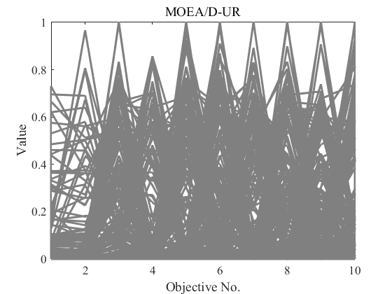 | 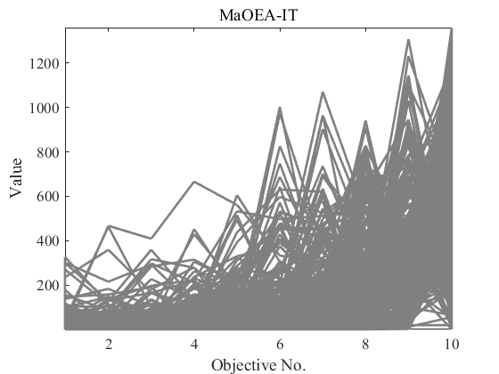 | 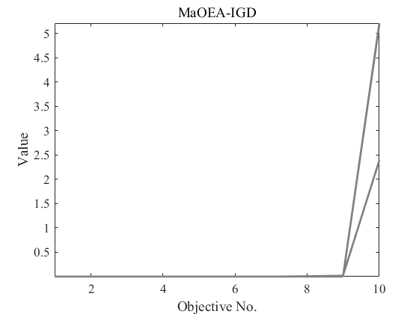
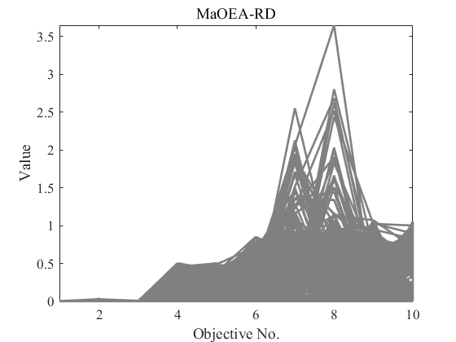 | 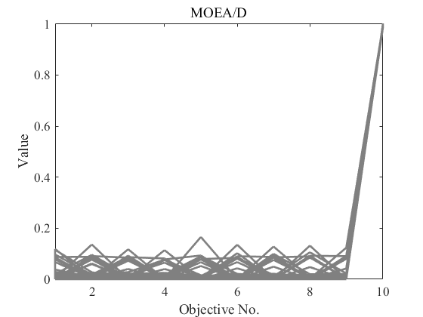 | 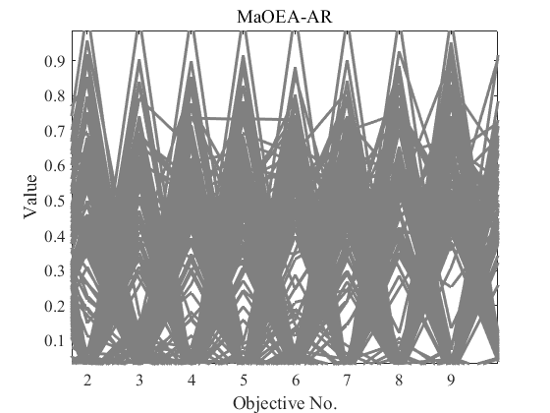
Figure 1. Distribution of solutions on DTLZ3 with 10-objective.

2.2 Performance on MaF
Tab.3 and Tab.4 give the statistical results for the six algorithms on the MaF test problem. The results show that MaOEA-AR shows the best performance both on HV and IGD. The HV statistics in Table 3 show that MaOEA-AR obtained 25 optimal values on 28 test instances and was able to handle almost all MaF test problems better, significantly better than the other five algorithms, with the proportion of test cases performing well being 21/28, 27/28, 28/28, 28/28 and 27/28 respectively. Different results for different indicators. In Tab.4, MaOEA-AR, while also significantly outperforming the other five algorithms, outperformed them by a different percentage. The proportions that performed well on the IGD were 26/28, 27/28, 26/28, 24/28 and 25/28, respectively. And optimal values were obtained for the objectives in any dimension of the MaF1, MaF2, MaF4 and MaF6 test problems. MOEA/D obtained the optimal value for the objective in any dimension of MaF5. No optimal values were obtained for MaOEA-UR and MaOEA-IT. Only 2 optimal values were obtained for both MaOEA-IGD and MaOEA-RD, respectively.
Table 3. Comparison of HV among the 6 algorithms on benchmarks MaF with 5-, 8-, 10- and 15-objective.
Table 4. Comparison of IGD among the 6 algorithms on benchmarks MaF with 5-, 8-, 10- and 15-objective.

2.3 Ablation Experiment
From the above experimental results, we can see that MaOEA-AR performs very well on DTLZ, MaF and WFG problems. To investigate the effectiveness of A-NDR, $k$-bit crossover and hybrid mutations, We subjected MaOEA-AR to ablation experiments on DTLZ4-7 and WFG5-9. MaOEA-AR\MS indicates no using $k$-bit crossover and mixed mutations in MaOEA-AR; MaOEA-AR\A-NDR no A-NDR used in MaOEA-AR, MaOEA-AR\MS+A-NDR indicates both are not included. The results of the HV and IGD experiments are given in Tab.5 and Tab.6, respectively. It can be seen that the MaOEA-AR variant using A-NDR and the mutation strategy performs better. The HV results in Tab.5 show that MaOEA-AR is superior to excluding MS, with proportions of 19/36, 28/36 and 31/36 for A-NDR and MS+A-NDR, respectively. This indicates that A-NDR can effectively select non-dominated solutions to join the population to improve convergence, maintain the balance between convergence and diversity, and enhance the performance of the algorithm. That replacing the traditional mutation strategy with $k$-bit crossover and hybrid mutation strategy can generate high-quality offspring and effectively improve the performance of the algorithm. Both MS and A-NDR contribute to the algorithm, but A-NDR makes a greater contribution and works best when both are used together. This conclusion can also be drawn from the IGD results in Tab.6. The results on the different indicators vary, with MaOEA-AR\MS being worse in 27 test instances, MaOEA-AR\A-NDR in 28 test instances and MaOEA-AR\MS+A-NDR in 32 test instances on IGD.

Table 5. Performance comparison of MaOEA-AR and its variant algorithms on HV for DTLZ4-7, WFG5-WFG9.

Table 6. Performance comparison of MaOEA-AR and its variant algorithms on IGD for DTLZ4-7, WFG5-WFG9.

References

- Y. Tian, H. D. Wang, X. Y. Zhang and Y. C.Jin, “Effectiveness and efficiency of non-dominated sorting for evolutionary multi-and many-objective optimization,” Complex & Intelligent Systems，vol.3, no. 4, pp. 247–263, 2017.
- H. Sato, H.E.Aguirre and K. Tanaka, “Controlling dominance area of solutions and its impact on the performance of moeas,” in International Conference on Evolutionary Multi-criterion Optimization, Matsushima, Japan, pp. 5–20, 2007.
- H. Sato, H.E.Aguirre, K.Tanaka, “Self-controlling dominance area of solutions in evolutionary many-objective optimization,” in Asia-Pacific Conference on Simulated Evolution and Learning, Kanpur, India, pp. 455–465, 2010.
[4] M. Farina and P. Amato, “A fuzzy definition of ”optimality” for many-criteria optimization problems,” IEEE Transactions on Systems, Man, and Cybernetics—Part A: Systems and Humans, vol.34, no.3, pp.315–326 , 2004.
[5] X. F. Zou, Y. Chen, M. Z. Liu and L. S. Kang, “A new evolutionary algorithm for solving many-objective optimization problems,” IEEE Transactions on Systems, Man, and Cybernetics—Part B: Cybernetics, vol.38, no.5, pp. 1402–1412, 2008.
[6] Y.Yuan, H. Xu, B.Wang and X.Yao, “A new dominance relation-based evolutionary algorithm for many-objective optimization,” IEEE Transactions on Evolutionary Computation, vol. 20, no.1, pp. 16–37, 2016.
[7] R.Cheng, Y.C.Jin, M.Olhofer and B.Sendhoff, “A reference vector guided evolutionary algorithm for many-objective optimization,” IEEE Transactions on Evolutionary Computation, vol.20, no.5, pp773–791, 2016.
[8] J. A. Cornell, “Experiments With Mixtures: Designs, Models, and the Analysis of Mixture Data,” vol. 403. New Y ork, NY , USA: Wiley, 2011.
[9] L. B. Ma, M. Huang, S. X. Yang, R. Wang and X.W. Wang, “An Adaptive Localized Decision Variable Analysis Approach to Large-Scale Multi-objective and Many-objective Optimization,” IEEE Transactions on Cybernetics, vol. 52, no. 7, pp. 6684-6696, July 2022.

